**FINANCIAL REGULATIONS**

**Table of Contents**

Question 1 3

Question 2 3

Question 3 6

Question 4 7

Question 5 8

Question 6 8

References 9

# Question 1

The Basel Accords (Basel I, Basel II, Basel 2.5, and Basel III) consistently have a significant impact on global financial regulation by improving capital adequacy. Basel I sets initial minimum standards while Basel II presents with risk-sensitive measures. Basel 2.5 responds to shortcomings resulting from the financial crisis of 2008, while Basel III enhances the regulation of liquidity and leverage ratios (Mitchell, 2022). Similarly, the Solvency II directive recalibrates risk management within European insurance through market valuation and capital adequacy standards. ICAAP helps banks manage the requisite capital levels adequately to its risk categories which in general brings stability to the banking system.

CRD IV synchronises European policies with Basel III by increasing capital, liquidity and leverage rules demanding improved compliance procedures in commercial banking. The Capital Requirements Regulation (CRR) regulates banks in the European Union by ensuring that the rules governing the banking sector are standardized (Neisen and Schulte-Mattler, 2022). These measures are set by the European Banking Authority (EBA) and implemented by the central banks to alter the operational dynamics and risk mitigation of the concerned banks. Major banks modify their asset portfolios and improve stress testing methodologies.

The Basel Endgame is particularly especially unkind to cryptocurrency holdings through conservative risk weights assumed to address volatility. It addresses downside risks related to digital assets and enhances the stability of the financial sector.

# Question 2

Securitization is defined as the buying out of loans or other assets and selling off the cash flows from those assets. The value of mortgage-backed securities (MBSs) and asset-backed securities (ABSs) lies in repackaging illiquid assets in the form of tradeable securities. Pass-through securities and other structures like CMOs make up the structures of appropriate MBS structures in the U.S. Agency MBS structures increase market liquidity (Hull, 2021). Securitization has transformed the banking landscape of the United States since the early 1990s through credit risk distribution and reduction in financing costs. However, excessive securitization increases risk, especially through non-transparent credit derivatives.

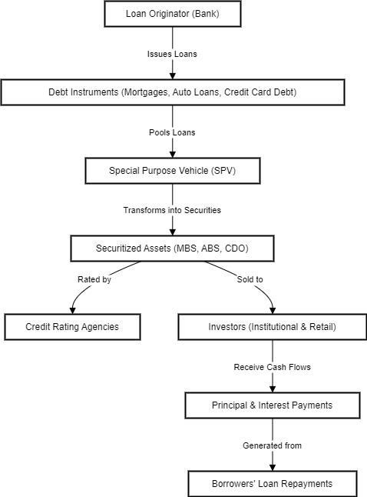

**Figure 1: Securitization Process Flowchart**

(Source: Acquired from Draw.io)

Credit Default Swaps (CDS) work like an insurance policy against losses for bond investors. CDS contracts are a key component of securitization allowing for the transfer of mortgage risks while at the same time promoting riskier lending. Private label securitization led to regulatory arbitrage through bypassing capital measures thus escalating the 2008 subprime crises. Partnoy and Skeel (2006) suggest that more standard disclosures, better credit ratings, and stronger bankruptcy termination rights would help overcome the threats of securitization. Their recommendations are consistent with the post-crisis policy changes that include the Dodd-Frank Act.

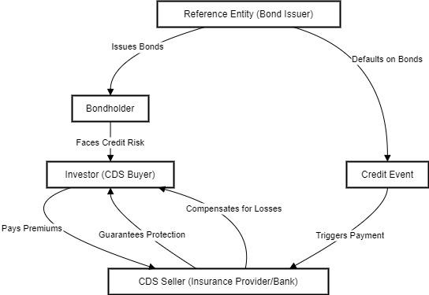

**Figure 2: Credit Default Swaps (CDS) Flowchart**

(Source: Acquired from Draw.io)

The April 2008 IMF Global Stability Report discusses the use of structured finance in the expansion of the market. However complex securitized products had the adverse effect of demoralizing investors. Collateralized Debt Obligations (CDOs) and CDO-squared instruments segment cash flow into risk tranches. Coval, Jurek, and Stafford (2009) noted that structured finance was very complex, which obstructed transparency and raised systemic risks.

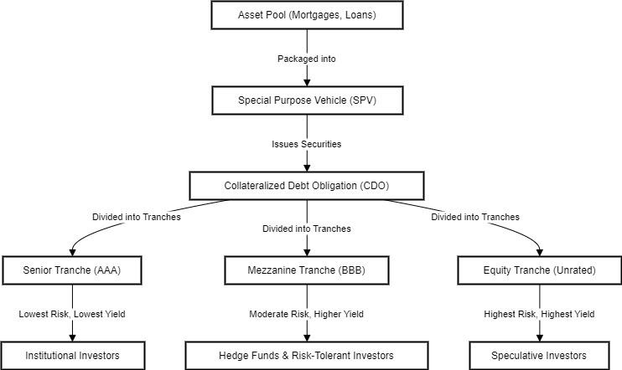

**Figure 3: CDO Structure Flowchart**

(Source: Acquired from Draw.io)

Basel III and other regulation initiatives such as the central clearing requirements are intended to help reduce risk-taking. Thus, the securitization framework remains a work in progress where credit derivatives are developed in tandem with lessons learned from past financial crises.

# Question 3

Partnoy (2002) claimed that there were four horsemen in U.S. derivatives regulation which include Greenspan, Summers, Levitt and Rubin. They opposed more oversight that resulted in the enaction of the Commodity Futures Modernization Act (2000) to exclude OTC derivatives from regulation. The obligations and risks were shifting from public law to ISDA master agreements thereby reducing the role of regulation. Cecchetti, Gyntelberg, and Hollanders (2009) supported the use of CCPs to eliminate counterpart risk. Mandatory clearing standards were implemented by Dodd-Frank in 2010 while EMIR in 2012 initiated standard trade repositories. Duffie (2018) suggested the usage of capital buffers, mandatory central clearing, and enhanced supervisory oversight to manage systemic risk in OTC markets. Minimizing credit risk is another advantage of margin accounts because they involve daily settlements (Hull, 2023).

The European Market Infrastructure Regulation (EMIR) seeks to increase transparency, minimize systemic risk, and mandate central counterparties for OTC derivatives. It also prescribes trade reporting and risk management requirements. MiFID II continues market structure reforms and investor protection measures and transparency enhancements, which creates issues in transaction reporting and altering the market structure.

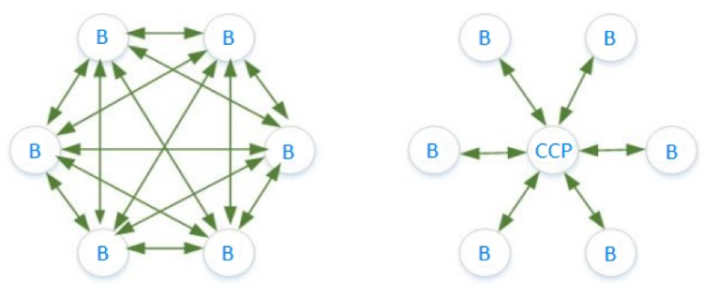

**Figure 4: CCP and Bilateral Clearing**

(Source: analystprep.com, 2025)

|  |  |  |
| --- | --- | --- |
| **Feature** | **Bilateral Clearing** | **CCP Clearing** |
| **Counterparty Risk** | Each party faces credit risk from its counterparty. | The CCP becomes the counterparty, reducing counterparty risk. |
| **Margin Requirements** | Lower and less standardized. | Higher and standardized margins reduce systemic risk. |
| **Default Management** | If one party defaults, the other absorbs the loss. | The CCP absorbs the loss, backed by default funds. |
| **Operational Efficiency** | Complex netting, high settlement costs. | Netting reduces trade exposure, making settlement efficient. |
| **Regulatory Oversight** | Less transparent, harder to monitor systemic risk. | Highly regulated with risk management practices. |

**Table 1: Key Differences Between Bilateral and CCP Clearing**

(Source: Self-created)

ESMA emerged as the EU Entity that standardizes the financial laws of all the member countries supervises markets and implements EMIR, MiFID, and MiFID II (Vasilca *et al.* 2022). This is because ESMA increases transparency and supervisory convergence, reduces systemic risk, and eliminates the possibilities of regulatory competition and arbitrage in the OTC markets.

# Question 4

According to Whelan (2011), overly liberal credit extension and a housing boom characterized Ireland’s sovereign debt crisis. Like other Eurozone crises, Ireland also experienced bank failures and fiscal deficits that led to enhancements of public debts through bank guarantees. The Basel Framework has been accused of overlooking underlying risks and tolerating high levels of leverage. The government could decrease moral hazard through an increase in capital adequacy requirements, conduct of stress testing and improvements in supervision. According to Partnoy (1999), the use of option theory serves to enhance corporate law through the areas of control, liability, and risk-shifting roles. Merton’s Credit Risk Model utilizes structural solutions to identify risks of default by showing the relation between debt and equity via graphical patterns.

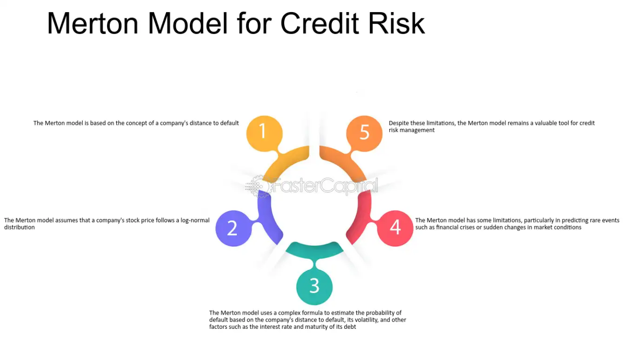

**Figure 5: Merton’s Theory on Credit Risk**

(Source: fastercapital.com, 2025)

According to Tung (2011) and Calomiris (1999) subordinated debt reduces moral hazard because creditors are subject to loss in the event of loan default thereby checkmating market actions. Unlike insured deposits as holders do not demand risk-based pricing, subordinated debt holders force banks to limit excessive risk-taking. But this decreases micro incentives distortions arising from government-backed guarantees, increasing financial steadiness and regulatory efficiency.

Bebchuk, Cohen and Spamann (2010) point out that banker pay relates to risk-taking incentives while Bell and Van Reenen (2014) focus on the issue of income inequality. CRD IV contains the bonus that may be moved from variable to fixed salary, which limits flexibility. In their opinion, Bebchuk and Spamann (2009) suggest long-term equity stakes unlike Bhagat and Romano (2009) who advocate for performance-related pay. According to Srivastav and Hagendorff (2016), inside debt such as deferred compensation reduces risk-taking since it directly links executives’ incentives with the stability of the bank.

# Question 5

**i)**



**Figure 6: Hyperlink with Google Colab and Present Value Calculation**

(Source: Acquired from Google Colab)

The word annuity denotes a financial arrangement in which regular payments of a fixed sum are made at fixed intervals for a specified period. It is often applied in retirement planning and loan repayments, and investments. Annuity is the key idea that future payments have a present value, which depends upon the time value of money in case you have received money now will be more than the same amount in future since this money will be able to earn. Annuities can be of ordinary or annuities due, where payments are to be made at the end of each period and beginning respectively.

They are widely used for example in finance, mortgage where you pay monthly with the intention of paying it fully by the end of the contract, and in retirement planning to receive a steady income when one stops working. Annuity concepts are also used by businesses and investors to estimate cash flows, calculate financial asset value, and decide on long term financial decisions. It means people and organizations will be able to make correct decisions about how to handle future monetary liabilities and investments if they comprehend annuities.

**ii)**

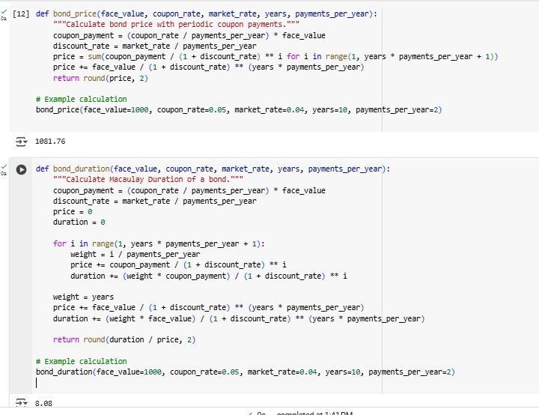

**Figure 7: Bond Price and Bond Distribution Calculation**

(Source: Acquired from Google Colab)

**Duration and how it affects managing interest rate risk**

Bond duration is a very important measure of interest rate risk that measures the interest rate sensitivity of a bond’s price. For example, a bond with a duration of 8.08 means that for each 1% rise in interest rates, the bond’s price decreases by about 8.08%. Likewise, if rates drop 1 percent, the price of the bond will increase by 1 percent, too.

Investors and financial institutions need to manage duration because they are able to evaluate how bond portfolios and fixed income assets react to interest rate changes. The more volatile and exposed to interest rate hikes is when duration is too high. However, during rising rates, shorter duration bonds are less rate sensitive, and so is a safer choice.

Duration management is vital for banks and pension funds to match their assets with liabilities. This means that if liabilities (deposits or other insurable amounts) are shorter lived than assets (long term bonds), a sudden rise in interest rate can create liquidity problems as there may be less value in long term investments.

**Managing the Duration of Assets and Liabilities – Importance to Financial Regulators (SVB Case Study)**

In the thumping that was Silicon Valley Bank (SVB) in March 2023, the collapse of an antiquated Silicon Valley traditional bank, financial regulators have been paying careful attention to the length of assets and liabilities on their balance sheets. According to SVB, it was low risk and therefore the mortgage-backed assets and government securities it had high exposure to be long duration bonds. But these bonds were of long duration, therefore very interest rate sensitive.

SVB’s holdings ballooned during the 2007 to 2009 property crisis as private mortgage insurance companies were unable to perform and defaulted, leading to massive losses by the bank when interest rates declined again in 2022-2023, when the Federal Reserve fought against inflation by massively increasing rates. As SVB faced liquidity pressure, the bank had to sell bonds at a $1.8 billion loss and, with depositors very nervous following the bank run, SVB failed quickly. The important lesson to be learned from this case is that duration risk should be managed so that liquidity crises can be prevented and financial resilience can be maintained.

iii)

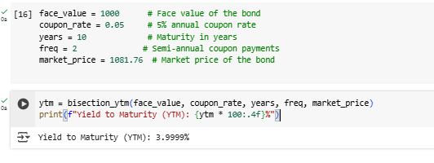

**Figure 8: Yield to Maturity Calculation**

(Source: Acquired from Google Colab)

The yield to maturity (YTM) of 3.9999% annualized appears as the annual return that an investor who buys the bond at its current market price of $1081.76 would earn by reinvesting all of the coupon payments at the same rate until maturity. As the Bisection Method is used to derive the YTM, and as such the discount rate associated with which an equation holds for the bond’s present value of future cash flows (coupons and face value) to be equal to the bond’s market price. The lower YTM indicates a bond is trading at a premium; hence the coupon rate is higher than prevailing market interest rates. YTM is used by investors to compare bond investments and determine interest rate risk when choosing or making decisions in the portfolio.

**iv)**

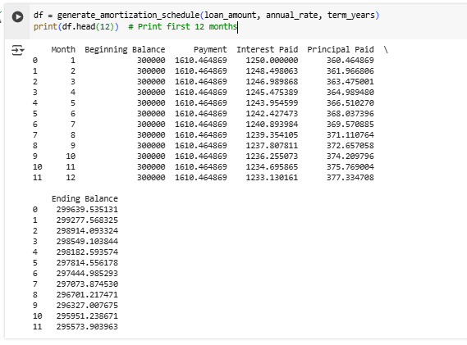

**Figure 9: Monthly Repayment on a Mortage**

(Source: Acquired from Google Colab)

**Effect of Changing Interest Rates on the Shape of IO and PO Strips**

**1. Interest Rate Increases**

When interest rates rise, it makes the refinancing of mortgage loans less attractive to borrowers. As a result, there is a longer loan duration, which prolongs the period of interest payments. Thus, the IO strip becomes more valuable in terms of continuation of interest payments dependency. In that sense, the principal of the PO strip is paid back on a slower basis than the investor would expect, thus causing the losing value of the PO strip.

**2. Interest Rate Decreases**

In other times, when interest rates fall, borrowers decide to refinance their loan to avail of lower interest rates. This speeds up principal repayments and increases the value of the PO strip since it takes investors less time to bail out at larger size. But the value of the IO strip is based on the fact that when borrowers pay down their loans early, the total amount of interest paid goes down.

**Separate Trading of IO and PO Strips in Markets**

**1. Interest-Only (IO) Strip Trading**

At high interest rates, IO strips attract investors due to the fact that borrowers hold onto their loans longer and pay sustained interest. Hedging against a decline in speed of prepayment is usually done with IO strips, to ensure steady flow of interest income.

**2. Principal-Only (PO) Strip Trading**

In a low interest rate environment, PO strips are more appealing considering borrowers repay their debt faster and refinancing activity rises. PO strips allow investors to receive early principal repayment and they prefer falling interest rates.

**3. Institutional Use of IO and PO Strips**

IO and PO strips are traded separately from hedge funds, mortgage-backed securities traders, and institutional investors to hedge against the interest rate risk and prepayment risk. They carry mix of IO and PO strips in order to balance their portfolios against the fluctuations in the mortgage market, seek optimal returns on the basis of the anticipated interest rate movements.

**v)**

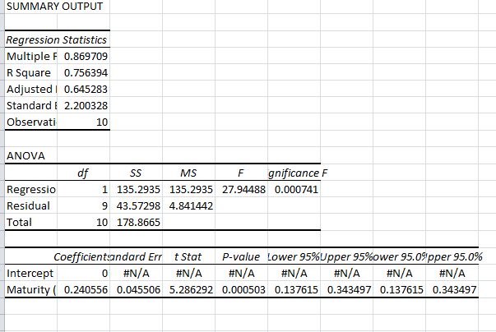

**Figure 10: Regression Analysis**

(Source: Acquired from Microsoft Excel)

It is used to estimate the term structure of interest rates using a linear model (dependent variable is continuous bond yield rates, and independent variable is maturity (years)). A value of 0.756 for this R-squared indicates that perhaps 75.6 percent of the variation in interest rates can be explained by maturity, meaning that there is a moderately strong but not perfect relationship. Indeed, there is a statistically significant (p.value = 0.00074) F statistic indicating that maturity matters for interest rates. As expected, the positive coefficient (0.2406) implies that yields raffle as maturity increases, i.e., there is an upward slop Nevertheless, residual analysis shows some deviation from the predicted values that possibly might suggest a more complex (e.g., polynomial), model to capture true term structure. This is consistent with expectations that, generally, a longer maturity will have a higher yield due to inflation risk and uncertainty regarding interest rates.

# Question 6

i)

Futures Price (F)

As the future price rises we increase the value of a call option. A call option gives the right to buy at a fixed strike price, and so the option becomes more valuable when the basis is increasing. Since the Black 76 model depends on F, for a higher F, the resulting d1 and d2 will be higher and this will lead to a higher option price.

Strike Price (K)

The value of call option is diminished if the strike price is high. The more the exercise price falls below futures price, the more probable it is that exercising the option will be profitable, and thus, the less valuable the option.

Time to Maturity (T)

The results are mixed in the effect of maturity. The larger the time to expiration, in general the greater the option value, as movement of the price in favor of the holder increases. Nevertheless, the capitalizing effect can be offset by a present value effect as, because the payoff is discounted using e^(-rT), Black-76 uses a discount rate of e^(-rT),.

Interest Rates (r)

The call option value is higher under higher interest rates. Since Black-76 contains terms such as e−rT that discount into the strike price, higher rates imply a lower value of present value of strike prices and thus, calls are more valuable. Furthermore, in futures markets, rates moving up in futures markets tend to have an upward effect on futures prices, helping call holders even more.

Volatility (σ)

The call option price increases as the volatility is increased. When the futures price is more volatile the option should be more attractive because higher price fluctuations enhance the probability of the futures price at maturity exceeding the strike price.

**How Can the American Analogue Be Valued?**

**Managing Interest Rate Risk**

Bond futures and its options give a way of hedging interest rate change. In such a case, the call option on bond futures earns a profit because bond prices and interest rates are inversely related and tend to rise when interest rates fall.

**Hedging Fixed-Income Portfolios**

Bond futures options are used by bond portfolio managers to hedge their portfolios. As an example, a pension fund which holds long term bonds and expects rising interest rates (which will lower bond prices) could purchase put options on bond futures for the purpose of offsetting the loss.

**Speculation on Rate Movements**

Instead, bond futures options are used by traders to speculate on interest rates movements. Buying a call option on bond futures would, for example, make sense for a trader who predicted that bond rates would fall because they can profit from higher bond prices.

Immunizing Against Rate Volatility

Hedge against interest rate volatility in callable bonds, mortgage backed securities, etc.

**ii)**

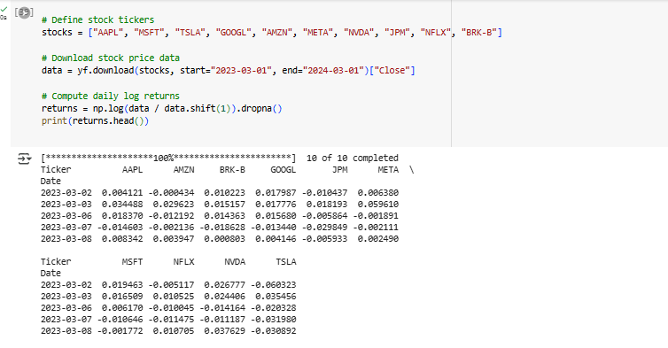

**Figure 11: Forming Stock Data**

(Source: Acquired from Google Colab)

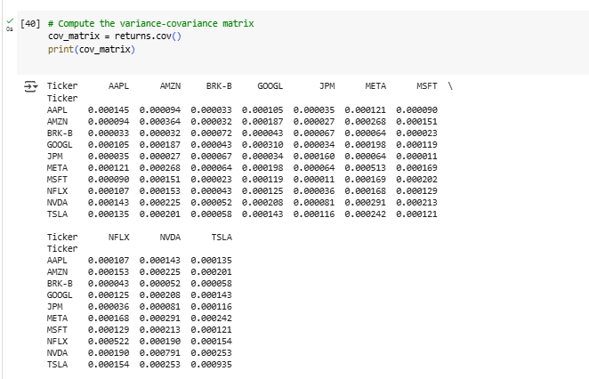

**Figure 12: Covariance Matrix**

(Source: Acquired from Google Colab)

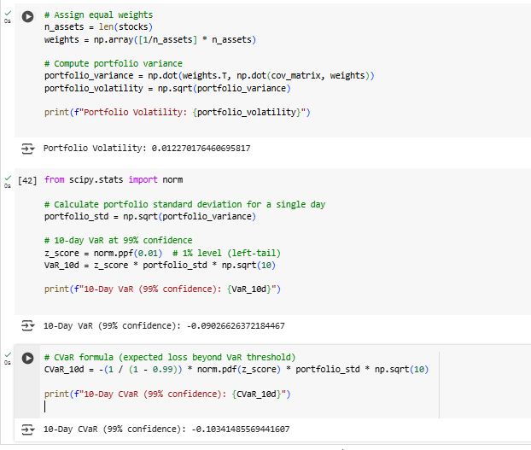

**Figure 13: Portfolio Volatility, 10-Day VAR, 10-Day cvAR Calculation**

(Source: Acquired from Google Colab)

The table is variance covariance matrix for a portfolio of 10 stocks which describe the way in which daily returns of one stock move in relation to another. The diagonal values assume the role of variance (or the individual stock risk), whereas the values off the diagonal represent correlation (or relationship between stocks). For instance, TSLA has the highest variance (0.000935) which means high volatility and BRK-B has the lowest (0.000072) which shows lower risk. Daily returns in the portfolio are expected to be low with an overall volatility of 1.23%. Value at Risk (VaR) at 99% confidence is – 9.03%, which means there is a 1% chance the portfolio could lose 9.03% or more over 10 days, or equivalently a 1% gain in 10 days is equivalent to a 9.03% loss. According to the Conditional VaR (CVaR), the expected loss is about 10.34% if the losses surpass VaR. They also play an important role in risk management, as investors need to get insights on the amount of potential downside risks prior to establishing an investment and fulfilling Basel regulations.

ii)

**Valuation of Executive Stock Options (ESOs) and Regulatory Importance**

However, Executive Stock Options (ESOs) are valued based on the option pricing models of Black Scholes (1989), Binomial Models, and Hull-White (2004) that used vesting periods, early exercise behavior and forfeiture rates. The restrictions on ESOs affect the way one would value them. To improve the cost estimation, Black-Scholes is modified to incorporate early exercise probabilities and dynamic holding strategies as done in the Hull-White model.

Under FAS 123(R), financial regulators such as the SEC (Securities and Exchange Commission) and FASB (Financial Accounting Standards Board) require firms to expense ESOs at fair value to be in accordance with that transparency requirement of the expenses in financial statements. It decreases earnings manipulation and increases the investor confidence while financial reporting is in line with actual economic cost. Nevertheless, there are challenges in estimating volatility, employee exercise behavior, and illiquidity discounts, all of which bring subjectivity into ESO valuation.

# References

Analystprep.com, (2025). *ccp-vs-bilateral-clearing*. Available at: https://analystprep.com/study-notes/frm/part-2/credit-risk-measurement-and-management/counterparty-risk-intermediation/attachment/ccp-vs-bilateral-clearing/ [Accessed on: 20/03/2025]

Bebchuk, L.A. and Spamann, H., 2009. Regulating bankers' pay. *Geo. lJ*, *98*, p.247. Access Link: https://heinonline.org/hol-cgi-bin/get_pdf.cgi?handle=hein.journals/glj98&section=12

Bebchuk, L.A., Cohen, A. and Spamann, H., 2010. The wages of failure: Executive compensation at Bear Stearns and Lehman 2000-2008. *Yale J. on Reg.*, *27*, p.257. Access Link: https://heinonline.org/hol-cgi-bin/get_pdf.cgi?handle=hein.journals/yjor27&section=12

Bell, B. and Van Reenen, J., 2014. Bankers and their bonuses. *The Economic Journal*, *124*(574), pp.F1-F21. Access Link: https://academic.oup.com/ej/article-abstract/124/574/F1/5078048

Bhagat, S. and Romano, R., 2009. Reforming executive compensation: Focusing and committing to the long-term. *Yale J. on Reg.*, *26*, p.359. Access Link: https://heinonline.org/hol-cgi-bin/get_pdf.cgi?handle=hein.journals/yjor26&section=13

Calomiris, C.W., 1999. Building an incentive-compatible safety net. *Journal of Banking & Finance*, *23*(10), pp.1499-1519. Access Link: https://www.sciencedirect.com/science/article/pii/S037842669900028X

Cecchetti, S.G., Gyntelberg, J. and Hollanders, M., 2009. Central counterparties for over-the-counter derivatives. *BIS Quarterly Review, September*. Access Link: https://papers.ssrn.com/sol3/papers.cfm?abstract_id=1472960

Coval, J., Jurek, J. and Stafford, E., 2009. The economics of structured finance. *Journal of Economic Perspectives*, *23*(1), pp.3-25. Access Link: https://www.aeaweb.org/articles?id=10.1257/jep.23.1.3

Duffie, D., 2018. Financial regulatory reform after the crisis: An assessment. *Management Science*, *64*(10), pp.4835-4857. Access Link: https://pubsonline.informs.org/doi/abs/10.1287/mnsc.2017.2768

Fastercapital.com, (2025). *Merton Model For Credit Risk*. Available at: https://fastercapital.com/topics/merton-model-for-credit-risk.html [Accessed on: 20/03/2025]

Hull, J., 2021. Options, Futures, and Other Derivatives, 11th global edition. Access Link: https://www.google.co.in/books/edition/Options_Futures_and_Other_Derivatives_Gl/sdg2EAAAQBAJ?hl=en

Hull, J., 2023. *Risk management and financial institutions*. United Kingdom: Wiley. Access Link: https://www.google.co.in/books/edition/Risk_Management_and_Financial_Institutio/WO6hEAAAQBAJ?hl=en&gbpv=0

Mitchell, C., 2022. The power of delay: Banking system structure and implementation of the Basel Accords. *Business and Politics*, *24*(1), pp.1-17. Access Link: https://www.cambridge.org/core/journals/business-and-politics/article/power-of-delay-banking-system-structure-and-implementation-of-the-basel-accords/5C4918757D02E92D86565A5EE58130A8

Neisen, M. and Schulte-Mattler, H., 2022. CRR III implementation: Impact on capital requirements, performance and business models of European banks. *Journal of Risk Management in Financial Institutions*, *15*(4), pp.338-361. Access Link: https://www.ingentaconnect.com/content/hsp/jrmfi/2022/00000015/00000004/art00003

Partnoy, F. and Skeel Jr, D.A., 2006. The promise and perils of credit derivatives. *U. Cin. L. Rev.*, *75*, p.1019. Access Link: https://heinonline.org/hol-cgi-bin/get_pdf.cgi?handle=hein.journals/ucinlr75&section=40

Partnoy, F., 1999. Adding Derivatives to the Corporate Law Mix. *Ga. L. Rev.*, *34*, p.599. Access Link: https://heinonline.org/hol-cgi-bin/get_pdf.cgi?handle=hein.journals/geolr34&section=23

Partnoy, F., 2002. The paradox of credit ratings. In *Ratings, rating agencies and the global financial system* (pp. 65-84). Boston, MA: Springer US. Access Link: https://link.springer.com/chapter/10.1007/978-1-4615-0999-8_4

Srivastav, A. and Hagendorff, J., 2016. Corporate governance and bank risk‐taking. *Corporate Governance: An International Review*, *24*(3), pp.334-345. Access Link: https://onlinelibrary.wiley.com/doi/abs/10.1111/corg.12133

Tung, F., 2011. Pay for banker performance: structuring executive compensation for risk regulation. *Nw. UL Rev.*, *105*, p.1205. Access Link: https://heinonline.org/hol-cgi-bin/get_pdf.cgi?handle=hein.journals/illlr105&section=38

Vasilca, M.M., Anton, G., Cheptis, A. and Vid, A.I., 2022. MIFID II and EMIR impact on Romanian banking system performance. In *Proceedings of the International Conference on Business Excellence* (Vol. 16, No. 1, pp. 732-749). Sciendo. Access Link: https://sciendo.com/pdf/10.2478/picbe-2022-0069

Whelan, K., 2011. Ireland’s sovereign debt crisis. Access Link: https://researchrepository.ucd.ie/handle/10197/6384